Speaker Consent Form | 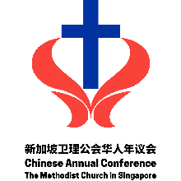

TO BE FILLED IN BY ORGANISER
1. | Event: | Click or tap here to enter text.
2. | Date: | Click or tap here to enter text.
3. | Organiser(s): | Click or tap here to enter text.
 | Support personnel: | Name: Click or tap here to enter text. |  | Contact: Click or tap here to enter text.
4. | Name of Speaker: | Click or tap here to enter text.
TO BE FILLED IN AND SIGNED BY SPEAKER
5. | I hereby consent for CAC to keep records of my presentation for:
 | Archival purposes
 | Sharing with event’s registered participants
 | Sharing with CAC pastors and churches
 | Sharing on CAC website, YouTube, social media platforms and/or in their print/digital newsletter
For the amendment/withdrawal of above consent(s),
please call or email the Chinese Annual Conference at 6478 4810 or cac@methodist.org.sg.
6. Signature & Date

Click or tap to enter a date.
TO BE FILLED IN BY RESPECTIVE BOARD CHAIRPERSON/IN-CHARGE
7. | Board Chair/In-charge: |  | Click or tap here to enter text.
8. | I approve for CAC to keep records of the speaker’s presentation for: |  |  | 9. Signature & Date:  Click or tap to enter a date.
 | Archival purposes
 | Sharing to event’s registered participants
 | Sharing to CAC pastors and churches
Sharing on CAC website, YouTube, social media platforms and/or
in their print/digital newsletter

